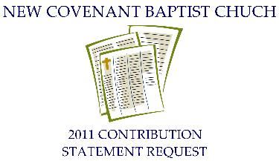

To: Board of Trustees
From: _________________________________________
I would like to request a copy of the charitable contributions that I made to New Covenant Baptist Church for the year 2011.
For your convenience, your statement may be sent to your e-mail address. If you prefer receiving your statement by e-mail, please indicate below by providing your e-mail address.
My e-mail address is: ______________________________
My updated information is:
Name: __________________________________________________
Address: ________________________________________________
Home Phone: ___________________ Cell Phone: ________________

Any member requesting a statement MUST fill out this form. Please allow the Trustees at least 2 to 3 weeks for processing.

