
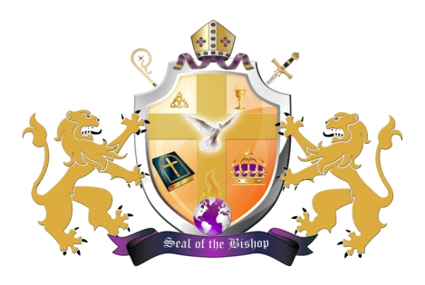

ORDER OF SERVICE
SUNDAY, MAY 13, 2012

PRESIDING MINISTER .................REVEREND MAXINE BLUNT

ORGAN PRELUDE……….……..…………........……….MUSICIANS

CALL TO WORSHIP………....................………………....PSALM 67

HYMN (#162) ……………………………………….“PASS ME NOT”

SCRIPTURE…………………….….........…..…….……...MINISTER

PRAYER……………………….……...........………………..DEACON

CHORALE RESPONSE…….…..………............ CONGREGATION

SELECTION…............................................INSPIRATIONAL CHOIR

BENEVOLENT OFFERING….........….USHERS AND MUSICIANS

ANNOUNCEMENTS……...…..….........……….. CHURCH CLERK

PASTORAL REMARKS…..…..…….........…..……BISHOP SMITH

GUESTS WELCOME…..............… HOSPITALITY COMMITTEE

SELECTION…………...............................INSPIRATIONAL CHOIR

OFFERTORY………………….........……..OFFICIALS IN CHARGE

SELECTION………..................................INSPIRATIONAL CHOIR

THE WORD…........................................................... BISHOP SMITH

FINAL REMARKS…..….........………..………...…BISHOP SMITH

INVITATION TO CHRISTIAN DISCIPLESHIP

BENEDICTION………..…..……….………………...BISHOP SMITH
ANNOUNCEMENTS
SUNDAY, MAY 13, 2012 @ 5:00PM
HAPPY MOTHER’S DAY. NO EVENING SERVICE

WEDNESDAY, MAY 16, 2012 @ 7:30PM
BISHOP GUEST PREACHER @ RESTORATION BIBLE CHURCH, PASTOR ALFIE LEWIS’ 5TH ANNIVERSARY, 6330 MARLBORO PIKE, DISTRICT HEIGHTS, MD (INSPIRATIONAL CHOIR ON DUTY)

THURSDAY, MAY 17, 2012 @ 7:30 PM
SINGLE WOMEN FELLOWSHIP

FRIDAY, MAY 18, 2012 @ 7:30 PM
EVANGELISTIC SERVICE: MINISTER JOAN BULLOCK

SATURDAY, MAY 19, 2012 @8:30AM
VOICES OF PRAISE CHOIR REHEARSAL

SATURDAY, MAY 19, 2012 @2PM
YOUNG ADULT CHOIR REHEARSAL

SATURDAY, MAY 19, 2012 @2PM
MINISTERIAL ALLIANCE MEETING

SUNDAY, MAY 20 @ 8:00 AM AND 11:00 AM
HOLY COMMUNION WILL BE SERVED FOLLOWING MORNING WORSHIP ON THIS SUNDAY ONLY
SUNDAY, MAY 20, 2012 @3:30 PM
BISHOP WILL BE THE GUEST PREACHER AT MT. ZION BAPTIST CHURCH, 5101 14TH STREET, N.W. (YOUNG ADULT CHOIR ON DUTY)

