
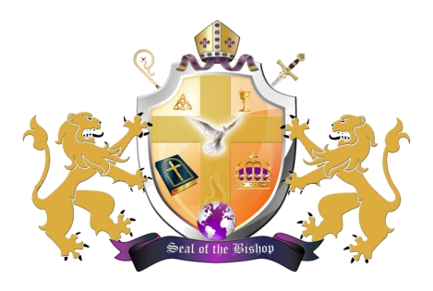

ORDER OF SERVICE
SUNDAY, MAY 20, 2012

PRESIDING MINISTER ....................MINISTER JOAN BULLOCK

ORGAN PRELUDE……….……..…………........……….MUSICIANS

CALL TO WORSHIP………....................………………....PSALM 67

HYMN (#079)………………………………………“AT THE CROSS”

SCRIPTURE…………………….….........…..…….……...MINISTER

PRAYER……………………….……...........………………..DEACON

CHORALE RESPONSE…….…..………............ CONGREGATION

SELECTION…............................................YOUNG ADULT CHOIR

BENEVOLENT OFFERING….........….USHERS AND MUSICIANS

ANNOUNCEMENTS……...…..….........……….. CHURCH CLERK

PASTORAL REMARKS…..…..…….........…..……BISHOP SMITH

GUESTS WELCOME…..............… HOSPITALITY COMMITTEE

SELECTION…………................................YOUNG ADULT CHOIR

OFFERTORY………………….........……..OFFICIALS IN CHARGE

SELECTION………....................................YOUNG ADULT CHOIR

THE WORD…........................................................... BISHOP SMITH

FINAL REMARKS…..….........………..………...…BISHOP SMITH

INVITATION TO CHRISTIAN DISCIPLESHIP

BENEDICTION………..…..……….………………...BISHOP SMITH
ANNOUNCEMENTS
SUNDAY, MAY 20, 2012 @ 8AM & 11AM
HOLY COMMUNION WILL BE SERVED AT BOTH SERVICES FOR THIS SUNDAY ONLY. COMMUNION FOR JUNE 17TH WILL RESUME AT 5PM.

SUNDAY, MAY 20, 2012 @ 3:30PM
BISHOP WILL BE THE GUEST PREACER @ MT. ZION BAPTIST CHURCH, 5101 14TH STREET N.W. THE YOUNG ADULT CHOIR WILL BE ON DUTY

WEDNESDAY, MAY 23, 2012 @ 6:30PM
NURSES MEETING

WEDNESDAY, MAY 23, 2012 @ 7PM
PRAYER SERVICE

WEDNESDAY, MAY 23, 2012 @ 7:30PM
BIBLE STUDY

THURSDAY, MAY 24, 2012 @ 7:30 PM
BISOP WILL BE THE GUEST PREACHER @ MASTER’S TOUCH MINISTRIES, 901 SOUTHERN AVE, OXON HILL, MD. THE YOUNG ADULT CHOIR WILL BE ON DUTY

FRIDAY, MAY 25, 2012 @ 7:30 PM
YOUNG ADULT SERVICE: GUEST PREACHER: DANNY PRINCE, ST. STEPHENS CHURCH

SATURDAY, MAY 26, 2012 @8:30AM
VOICES OF PRAISE CHOIR REHEARSAL

SATURDAY, MAY 26, 2012 @3PM
YOUNG ADULTS MEET WITH BISHOP

