NEW COVENANT BAPTIST CHURCH A P R I L 2011
Sun |  |  | Mon | Tues | Wed |  |  | Thu | Fri |  |  | Sat
 |  |  |  |  |  |  |  |  | 1  8:00 PM  Bishop’s Appreciation  Service  (Sponsored by PRT) |  |  | 2  1:00 PM  Inspirational Choir  Rehearsal
3  5:00 p.m.  New Covenant  At Home  Service |  | 4  7:00 p.m.  DEACONS’  MEETING |  | 5 | 6  6:00 p.m.  Missionary Meeting  7:00 p.m.  Prayer Service  7:30 p.m.  Bible Study |  |  | 7  7:30 PM  Bishop will be the Guest Preacher at Deliverance Miracle Temple, 1100 Bladensburg Road, NE.  Bishop’s Choir/duty | 8  7:00 PM  KWWWT Officers’  Meeting  8:00 PM  New Covenant At Home Service |  |  | 9  8:30 AM  Voices of Praise  Rehearsal  12:00 Noon  Inspirational Choir  Rehearsal  3:00 PM  KWWWT Monthly Fellowship
10  5:00 p.m.  New Covenant  At Home  Service |  | 11 |  | 12  7:30 p.m.  Men’s Monthly  Fellowship | 13  6:00 p.m.  Ushers’ Meeting  7:00 p.m.  Prayer Service  7:30 p.m.  Bible Study |  |  | 14  7:00 PM  Male Chorus Rehearsal  7:00 PM  Singles Fellowship | 15  7:30 PM  Bishop will be the Guest Preacher at the Gethsemane Baptist Church, 7820 Penn Western Court, Upper Marlboro, Md.  Inspirational Choir/duty |  |  | 16  8:30 AM  Voices of Praise Rehearsal  4:00 PM  Ministerial Alliance  Meeting
17  Palm  Sunday  5:00 p.m.  Holy Communion |  | 18 |  | 19  7:30 p.m.  Bishop’s Choir Rehearsal | 20  7:00 p.m.  Prayer Service  7:30 p.m.  Bible Study |  |  | 21  10;00 AM to 2:00 PM  Senior Adult Ministries’ Easter Celebration  7:00 PM  Male Chorus Rehearsal | 22  8:00 p.m.  LAST SEVEN SAYINGS |  |  | 23 | ``
24  6:00 a.m.  Easter Sunday Sunrise Service  11:00 a.m.  Morning Worship |  | 25 |  | 26  7:30 p.m.  Bishop’s Choir Rehearsal | 27  6:00 p.m.  Nurses’ Meeting  7:00 p.m.  Prayer Service  7:30 p.m.  Bible Study |  |  | 28  7:00 PM  Singles Fellowship | 29 |  |  | 30  Trip to the Sight and Sound Center, Lancaster, Pennsylvania to see the production of “JOSEPH”
29

Sun |  | Mon | Tue |  | Wed |  | Thu |  |  | Fri | Sat
 | New Covenant Baptist Church  Bishop A. Norris Smith, Pastor  801 44th Street, N.E.  Washington, D.C. 20019  Phone: (202) 397-3115 or (202) 397-3116  Calendar Line: (202) 397-3767  (Up-to-date calendar information) |  |  | 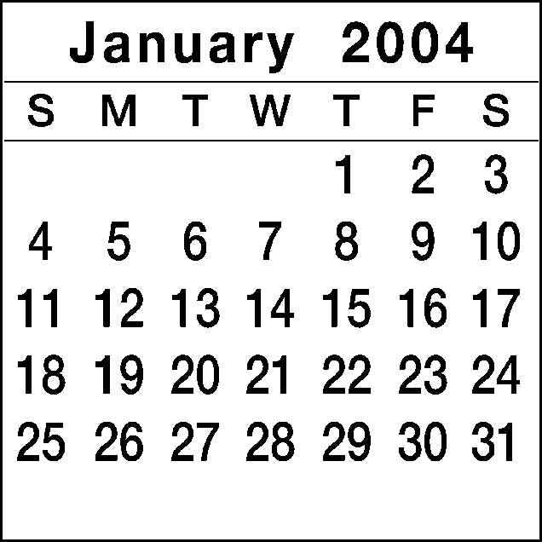 |  | 1    NEW YEAR’S DAY  “LOVE IS THE KEY” |  |  | 2  8:00 P.M.  Bishop Smith’s Appreciation Service |  |  | 3  10:00 a.m.  Voices of Praise Rehearsal
4  6:00 P.M.  First Public Message  ANGELA DYER |  | 5 | 6  12:00 P.M.  Noon Day Prayer  Colonial Beach  Bible Study |  | 7  6:30 P.M.  Missionary Meeting  7:30 P.M.  Prayer Service  8:00 P.M.  Bible Study |  |  | 8  7:30 P.M.  Male Chorus Rehearsal | 9  8:00 P.M.  Building Fund Service |  |  | 10  3:00 p.m.  KWWWT Ministry
11  5:00 p.m. Tribe of Reuben Building Fund Service  Guest: Pastor Abner Carey & New Grove Missionary Baptist Church |  | 12 | 13  12:00 P.M.  Noon Day Prayer  Colonial Beach  Bible Study |  | 14  6:30 P.M.  Usher Board  7:30 P.M. |  |  | 15  7:30 P.M.  Bishop Appreciation Service | 16  8:00 P.M.  Bishop Appreciation Service |  |  | 17  11:00 a.m.  Mature Women  1:00 p.m.  Gospel Chorus Rehearsal
18  5:00 p.m. Bishop Smith and New Covenant to Strafford Hall, Colonial Beach, Virginia (Voices of Praise) (Dedication of Emmanuel Christian Center) |  | 19  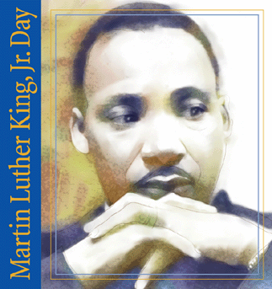  Martin Luther King, Jr. Day | 20  12:00 P.M.  Noon Day Prayer  Colonial Beach  Bible Study |  | 21  6:30 P.M.  Trustee Board  7:30 P.M.  Prayer Service  8:00 P.M.  Bible Study |  |  | 22  7:30 P.M.  Sanctuary Choir Rehearsal  8:00 P.M.  Single Women’s Ministry | 23  8:00 P.M.  KWWWT Ministry  Pre-Women’s Day Service  Guest Preacher: Prophetess Stephanie Harris |  |  | 24  10:00 a.m.  Voices of Praise Rehearsal  1:00 p.m.  Gospel Chorus Rehearsal
25  5:00 p.m.  KWWWT 15th Year Anniversary |  | 26  6:00-9:00 p.m.  SBCBI Winter/Spring Quarter | 27  12:00 P.M.  Noon Day Prayer  Colonial Beach  Bible Study |  | 28  6:30 P.M.  Nurse’ Board Meeting  7:30 P.M.  Prayer Service  8:00 P.M.  Bible Study |  |  | 29  6:00-7:30 p.m.  SCBI Classes  7:30 P.M.  Sanctuary Choir Rehearsal |  | 30  8:00 P.M.  Usher Board Service |  | 31  10:00 a.m.  Voices of Praise
29

