New Covenant Baptist Church
Bishop A. Norris Smith, Pastor
1301 W Street, SE
Washington, DC 20020
(202) 678-1314

We invite you to join us in the 27th year
P A S T O R A L C E L E B R A T I O N
for Bishop A. Norris Smith

PSALM 37:23
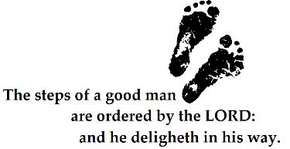
Sunday, February 26 @ 5:00 p.m.
Pastor Debra McAlpine
Word of Hope Deliverance Ministries
Monday, February 27 @ 7:30 p.m.
Pastor Regretta Ruffin
Greater New St. Paul Baptist Church
Tuesday, February 28 @ 7:30 p.m.
Pastor John E. Maddox
Gethsemane Baptist Church
Wednesday, February 29 @ 7:30 p.m.
Pastor Abner Carey
New Grove Missionary Baptist Church

Thursday, March 1 @ 7:30 p.m.
TBD
Friday, March 2, @ 7:30 p.m.
Pastor George Fitzgerald
Freedom Way Missionary Baptist Church
27TH YEAR ANNIVERSARY CELEBRATION BANQUET
SATURDAY, MARCH 3, 2012
4:00 P.M. TO 8:00 P.M.
THE WASHINGTON NAVY YARD
WASHINGTON, DC.
Donations: $60.00
For additional information or for tickets:
Please contact Reverend Maxine Blunt @
240-731-0126

