NEW COVENANT BAPTIST CHURCH JULY 2011
Sun |  |  | Mon | Tues | Wed |  |  | Thu | Fri |  |  | Sat
 |  |  |  |  |  |  |  |  | 1  7:30 p.m.  PRT  Bishop’s Birthday Celebration |  |  | HAPPY  BIRTHDAY TO  BISHOP  A.  NORRIS  SMITH
3  5:00 p.m.  Guest Preacher: Pastor Vernon E. Thompson and the Macedonia New & Living Way Church will be our guests |  | 4   |  | 5  7:00 p.m.  Deacons’  Meeting | 6  7:15 p.m.  Bishop will be the Guest Preacher at the Solid Rock Missionary Baptist Church, 4725 Silver Hill Road, Suitland, Md.  Bishop’s Choir will be on duty |  |  | 7 | 8  7:00 PM  KWWWT Officers’  Meeting  7:30 PM  New Covenant In House Service |  |  | 9
10  5:00 p.m.  Pre-Men’s Day Service: Guest Preacher: Apostle Dr. James G. Coleman and Spiritual Guidance ICOG |  | 11  7:00 PM to 8:00 PM  Praise Away the Pounds with Zumba  Fitness  ($5.00 per session/  New Covenant Members only) |  | 12 | 13  6:00 p.m.  Ushers’ Meeting  7:00 p.m.  Prayer Service  7:30 p.m.  Bible Study |  |  | 14  10:00 AM  Senior Citizens’  Monthly Outing  7:00 PM  Singles Fellowship  7:00 PM  Male Chorus Rehearsal | 15  7:30 PM  Bishop will be the Guest Preacher at Liberty Empowerment Baptist Church for Healing and Deliverance Service |  |  | 16  8:30 AM  Voices of Praise Rehearsal  3:00  Ministerial  Alliance  Meeting
17  5:00 p.m.  Holy Communion  Worship Service |  | 18  7:30 PM  Bishop will be the Guest Preacher at Shining Star Missionary Church, 5737 Martin Luther King, Jr. Highway  (Voices of Praise/Duty) |  | 19  7:30 p.m.  Bishop’s Choir  Rehearsal | 20  7:00 p.m.  Prayer Service  7:30 p.m.  Bible Study |  |  | 21  7:00 PM  Male Chorus Rehearsal | 22  Men’s  Retreat |  |  | 23  Men’s  Retreat | ``
24  5:00 PM  Men’s Day Service  31  5:00 PM  Missionary Day Service  Guest Preacher: Rev. Dr. Gregory Baldwin |  | 25  7:00 PM to 8:00 PM  Praise Away the Pounds with Zumba  Fitness |  | 26  7:30 p.m.  Bishop’s Choir  Rehearsal | 27  6:00 p.m.  Nurses’ Meeting  7:00 p.m.  Prayer Service  7:30 p.m.  Bible Study |  |  | 28 | 29  Women’s  Retreat |  |  | 30  Women’s  Retreat
29

Sun |  | Mon | Tue |  | Wed |  | Thu |  |  | Fri | Sat
 | New Covenant Baptist Church  Bishop A. Norris Smith, Pastor  801 44th Street, N.E.  Washington, D.C. 20019  Phone: (202) 397-3115 or (202) 397-3116  Calendar Line: (202) 397-3767  (Up-to-date calendar information) |  |  | 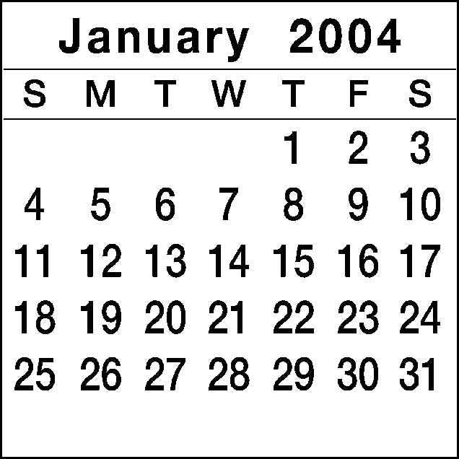 |  | 1    NEW YEAR’S DAY  “LOVE IS THE KEY” |  |  | 2  8:00 P.M.  Bishop Smith’s Appreciation Service |  |  | 3  10:00 a.m.  Voices of Praise Rehearsal
4  6:00 P.M.  First Public Message  ANGELA DYER |  | 5 | 6  12:00 P.M.  Noon Day Prayer  Colonial Beach  Bible Study |  | 7  6:30 P.M.  Missionary Meeting  7:30 P.M.  Prayer Service  8:00 P.M.  Bible Study |  |  | 8  7:30 P.M.  Male Chorus Rehearsal | 9  8:00 P.M.  Building Fund Service |  |  | 10  3:00 p.m.  KWWWT Ministry
11  5:00 p.m. Tribe of Reuben Building Fund Service  Guest: Pastor Abner Carey & New Grove Missionary Baptist Church |  | 12 | 13  12:00 P.M.  Noon Day Prayer  Colonial Beach  Bible Study |  | 14  6:30 P.M.  Usher Board  7:30 P.M. |  |  | 15  7:30 P.M.  Bishop Appreciation Service | 16  8:00 P.M.  Bishop Appreciation Service |  |  | 17  11:00 a.m.  Mature Women  1:00 p.m.  Gospel Chorus Rehearsal
18  5:00 p.m. Bishop Smith and New Covenant to Strafford Hall, Colonial Beach, Virginia (Voices of Praise) (Dedication of Emmanuel Christian Center) |  | 19  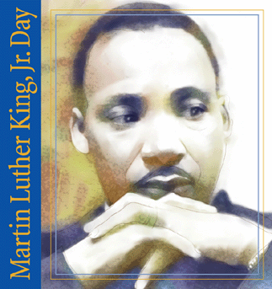  Martin Luther King, Jr. Day | 20  12:00 P.M.  Noon Day Prayer  Colonial Beach  Bible Study |  | 21  6:30 P.M.  Trustee Board  7:30 P.M.  Prayer Service  8:00 P.M.  Bible Study |  |  | 22  7:30 P.M.  Sanctuary Choir Rehearsal  8:00 P.M.  Single Women’s Ministry | 23  8:00 P.M.  KWWWT Ministry  Pre-Women’s Day Service  Guest Preacher: Prophetess Stephanie Harris |  |  | 24  10:00 a.m.  Voices of Praise Rehearsal  1:00 p.m.  Gospel Chorus Rehearsal
25  5:00 p.m.  KWWWT 15th Year Anniversary |  | 26  6:00-9:00 p.m.  SBCBI Winter/Spring Quarter | 27  12:00 P.M.  Noon Day Prayer  Colonial Beach  Bible Study |  | 28  6:30 P.M.  Nurse’ Board Meeting  7:30 P.M.  Prayer Service  8:00 P.M.  Bible Study |  |  | 29  6:00-7:30 p.m.  SCBI Classes  7:30 P.M.  Sanctuary Choir Rehearsal |  | 30  8:00 P.M.  Usher Board Service |  | 31  10:00 a.m.  Voices of Praise
29

