NEW COVENANT BAPTIST CHURCH MARCH 2011
Sun |  |  | Mon | Tues | Wed |  | Thu |  | Fri |  |  | Sat
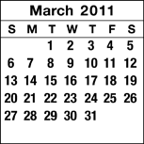 |  |  |  |  | 2  6:00 p.m.  Missionary Meeting  7:00 p.m.  Prayer Service  7:30 p.m.  Bible Study |  | 3 |  | 4  8:00 PM  Bishop’s will be the Guest Preacher at Church of Love, Hope & Faith  9600 Edgeworth Drive,  Capital Heights, Md  Bishop’s Choir on Duty |  |  | 5  Homegoing  service  all rehearsals have  been cancelled
6  5:00 p.m.  HEALING AND DELIVERANCE  POOL PARTY |  | 7  7:00 p.m.  DEACONS’  MEETING |  | 8 | 9  6:00 p.m.  Ushers’ Meeting  7:00 p.m.  Prayer Service  7:30 p.m.  Bible Study |  | 10  7:00 p.m.  Singles Fellowship |  | 11  7:30 PM  Meeting with ALL  Ordained Clergy |  |  | 12  9:00 AM  Voices of Praise Rehearsal  12:00 Noon  Inspirational Choir  Rehearsal  2:00 pm  KWWWT Officers’ Meeting  3:00 PM  KWWWT Monthly Fellowship  “A Deadly Weapon”
13  5:00 p.m.  VOP Anniversary Service  Guest Preacher: Bishop Nehemiah  Rhinehart and Solid Rock Full Gospel Church |  | 14 |  | 15 | 16  7:00 p.m.  Prayer Service  7:30 p.m.  Bible Study |  | 17  7:00 p.m.  Male Chorus Rehearsal |  | 18  8:00 p.m.  Bishop will be the Guest Preacher at Anacostia Full Gospel Church,  1320 U Street, S.E.  (Inspirational Choir on duty) |  |  | 19  9:00 a.m.  Voices of Praise Rehearsal
20  5:00 PM  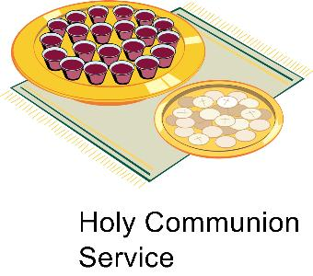 |  | 21 |  | 22 | 23  6:00 p.m.  Nurses’ Meeting  7:00 p.m.  Prayer Service  7:30 p.m.  Bible Study |  | 24  7:00 p.m.  Male Chorus Rehearsal  7:00 p.m.  Singles Fellowship |  | 25  8:00 p.m.  New Covenant  In-House Service |  |  | 26 | ``
27  5:00 p.m.  Guest Preacher: Pastor Dwight Bynum and  Shekinah Glory Deliverance Church |  | 28
29

Sun |  | Mon | Tue |  | Wed |  | Thu |  |  | Fri | Sat
 | New Covenant Baptist Church  Bishop A. Norris Smith, Pastor  801 44th Street, N.E.  Washington, D.C. 20019  Phone: (202) 397-3115 or (202) 397-3116  Calendar Line: (202) 397-3767  (Up-to-date calendar information) |  |  | 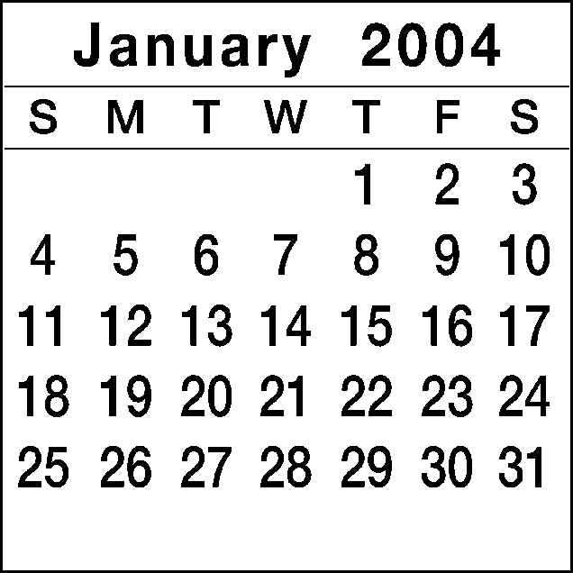 |  | 1    NEW YEAR’S DAY  “LOVE IS THE KEY” |  |  | 2  8:00 P.M.  Bishop Smith’s Appreciation Service |  |  | 3  10:00 a.m.  Voices of Praise Rehearsal
4  6:00 P.M.  First Public Message  ANGELA DYER |  | 5 | 6  12:00 P.M.  Noon Day Prayer  Colonial Beach  Bible Study |  | 7  6:30 P.M.  Missionary Meeting  7:30 P.M.  Prayer Service  8:00 P.M.  Bible Study |  |  | 8  7:30 P.M.  Male Chorus Rehearsal | 9  8:00 P.M.  Building Fund Service |  |  | 10  3:00 p.m.  KWWWT Ministry
11  5:00 p.m. Tribe of Reuben Building Fund Service  Guest: Pastor Abner Carey & New Grove Missionary Baptist Church |  | 12 | 13  12:00 P.M.  Noon Day Prayer  Colonial Beach  Bible Study |  | 14  6:30 P.M.  Usher Board  7:30 P.M. |  |  | 15  7:30 P.M.  Bishop Appreciation Service | 16  8:00 P.M.  Bishop Appreciation Service |  |  | 17  11:00 a.m.  Mature Women  1:00 p.m.  Gospel Chorus Rehearsal
18  5:00 p.m. Bishop Smith and New Covenant to Strafford Hall, Colonial Beach, Virginia (Voices of Praise) (Dedication of Emmanuel Christian Center) |  | 19  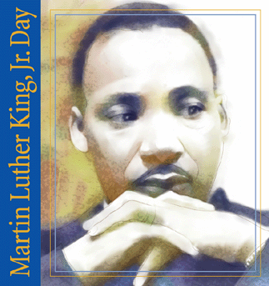  Martin Luther King, Jr. Day | 20  12:00 P.M.  Noon Day Prayer  Colonial Beach  Bible Study |  | 21  6:30 P.M.  Trustee Board  7:30 P.M.  Prayer Service  8:00 P.M.  Bible Study |  |  | 22  7:30 P.M.  Sanctuary Choir Rehearsal  8:00 P.M.  Single Women’s Ministry | 23  8:00 P.M.  KWWWT Ministry  Pre-Women’s Day Service  Guest Preacher: Prophetess Stephanie Harris |  |  | 24  10:00 a.m.  Voices of Praise Rehearsal  1:00 p.m.  Gospel Chorus Rehearsal
25  5:00 p.m.  KWWWT 15th Year Anniversary |  | 26  6:00-9:00 p.m.  SBCBI Winter/Spring Quarter | 27  12:00 P.M.  Noon Day Prayer  Colonial Beach  Bible Study |  | 28  6:30 P.M.  Nurse’ Board Meeting  7:30 P.M.  Prayer Service  8:00 P.M.  Bible Study |  |  | 29  6:00-7:30 p.m.  SCBI Classes  7:30 P.M.  Sanctuary Choir Rehearsal |  | 30  8:00 P.M.  Usher Board Service |  | 31  10:00 a.m.  Voices of Praise
29

